

**Requirement Specifications**

**For Nursing Home Management System**

Version: 0.1

Table of Contents

**1. Introduction 2**

1.1. Purpose 2

1.2. Overview 2

**2. High Level Requirements 2**

2.1. Admin 2

2.2. HR 4

2.3. Accountant 5

2.4. Doctor 6

2.5. Nurse 7

2.6. User 8

# 1. Introduction

## 1.1. Purpose

The Functional Requirements Specification will:

* Define the scope of business objectives, business functions, and organisational units covered.
* Identify the business processes that the solution must facilitate.
* Facilitate a common understanding of what the functional requirements are for all parties involved.
* Establish a basis for defining the acceptance tests for the solution to confirm that what is delivered meets requirements.

The purpose of the document is to collect and analyse all assorted ideas that have come up to define the system, its requirements with respect to consumers. Also, we shall predict and sort out how we hope this product will be used in order to gain a better understanding of the project, outline concepts that may be developed later, and document ideas that are being considered, but may be discarded as the product develops.

## 1.2. Overview

The Nursing Home Management System (NHMS) is a comprehensive software solution designed to effectively manage and streamline the operations of a nursing home. NHMS includes a wide range of features including user management, human resource administrative management, nursing home financial management.

# 2. High Level Requirements

This section describes the general overview of the system functions or business processes which are depicted in different diagrams. It shows the types of users, their granted permissions to perform specific system functions and the sequence required to complete a business workflow. For detailed requirement specification, please see the section below.

## 2.1. Admin

When users use the admin account to log in to the system, they will see an interface like the one below. The admin role in the system will manage all functions in the system, including the following functions:

+ Manage actors such as accountants, HR, doctors, nurses, pharmacists.

+ Manage and use sub-functions in the system.

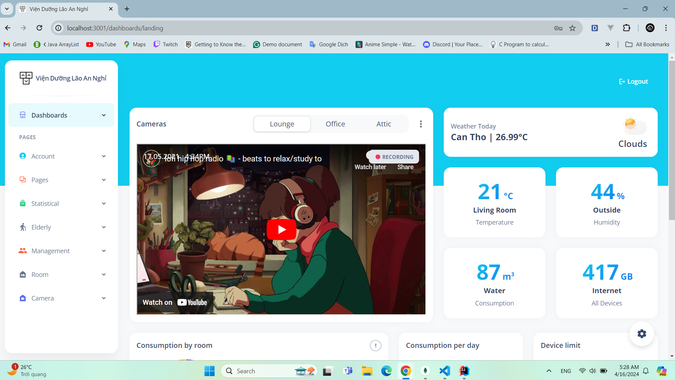

The image below is the admin's personal profile

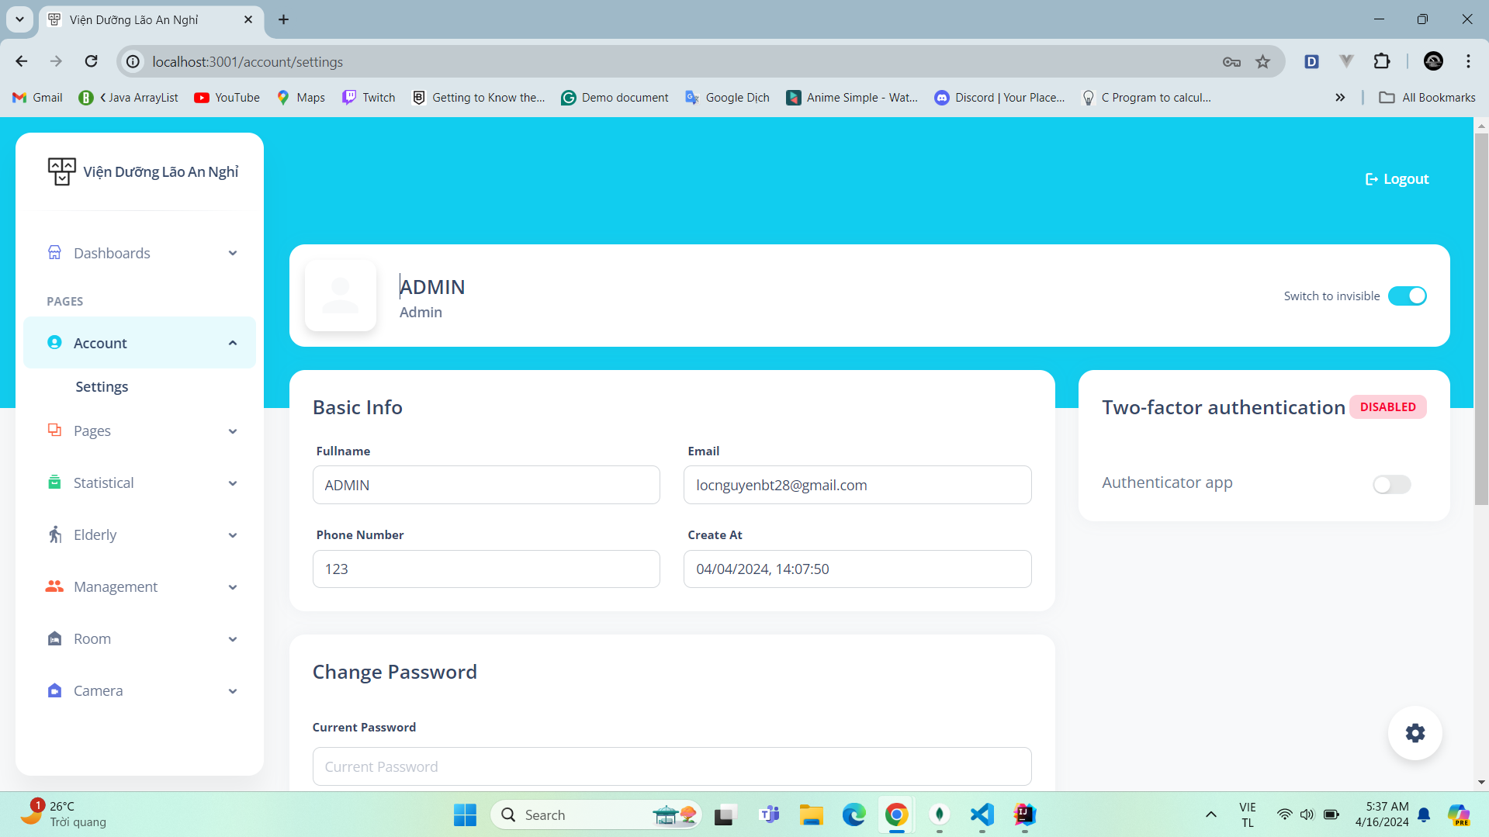

## 2.2. HR

When users use their HR account to log in to the system, they will see the interface as below. The HR role in the system will manage all information related to user information of the system, including the following functions:

+ Manage personnel information, administrative records, information of the elderly and relatives.

+ Manage and use sub-functions in the system related to HR functions.

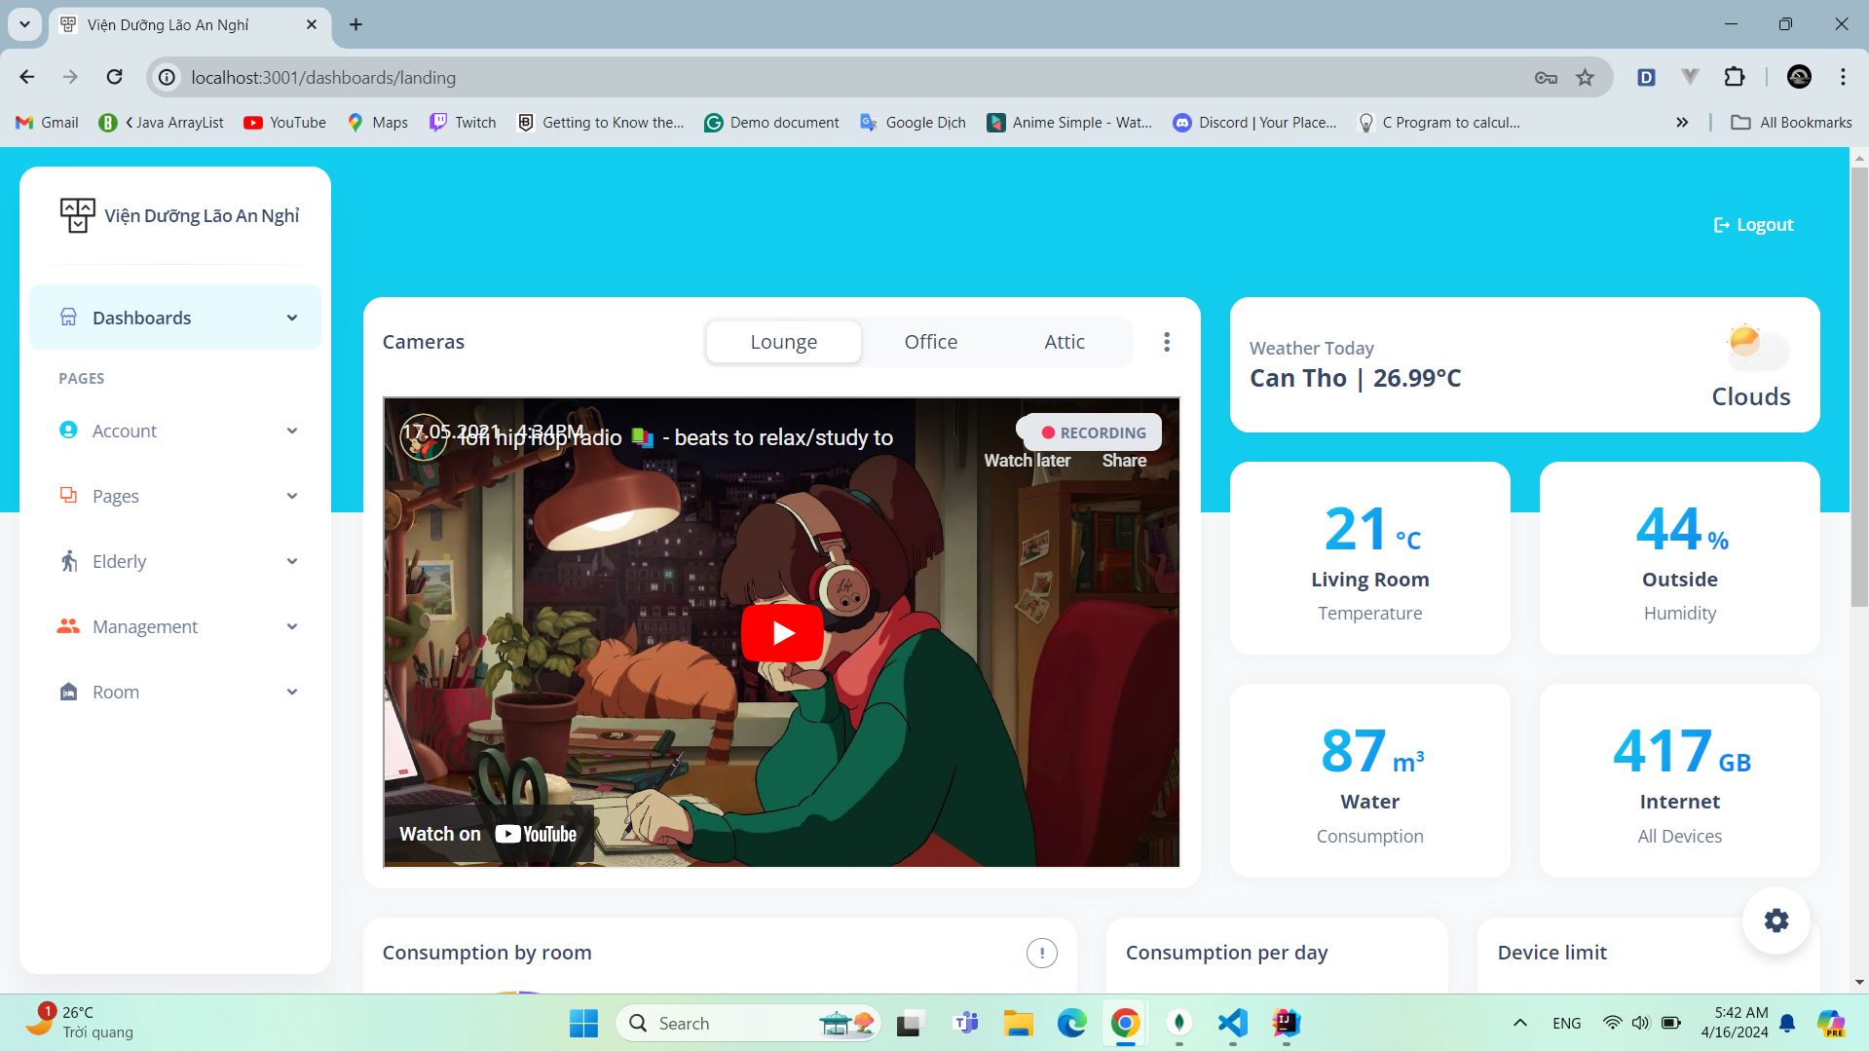

The sidebar on the left side of the screen in the image below are the functions that HR can use:

+ Administrative records of the elderly.

+ Manage human resource information in the nursing home system.

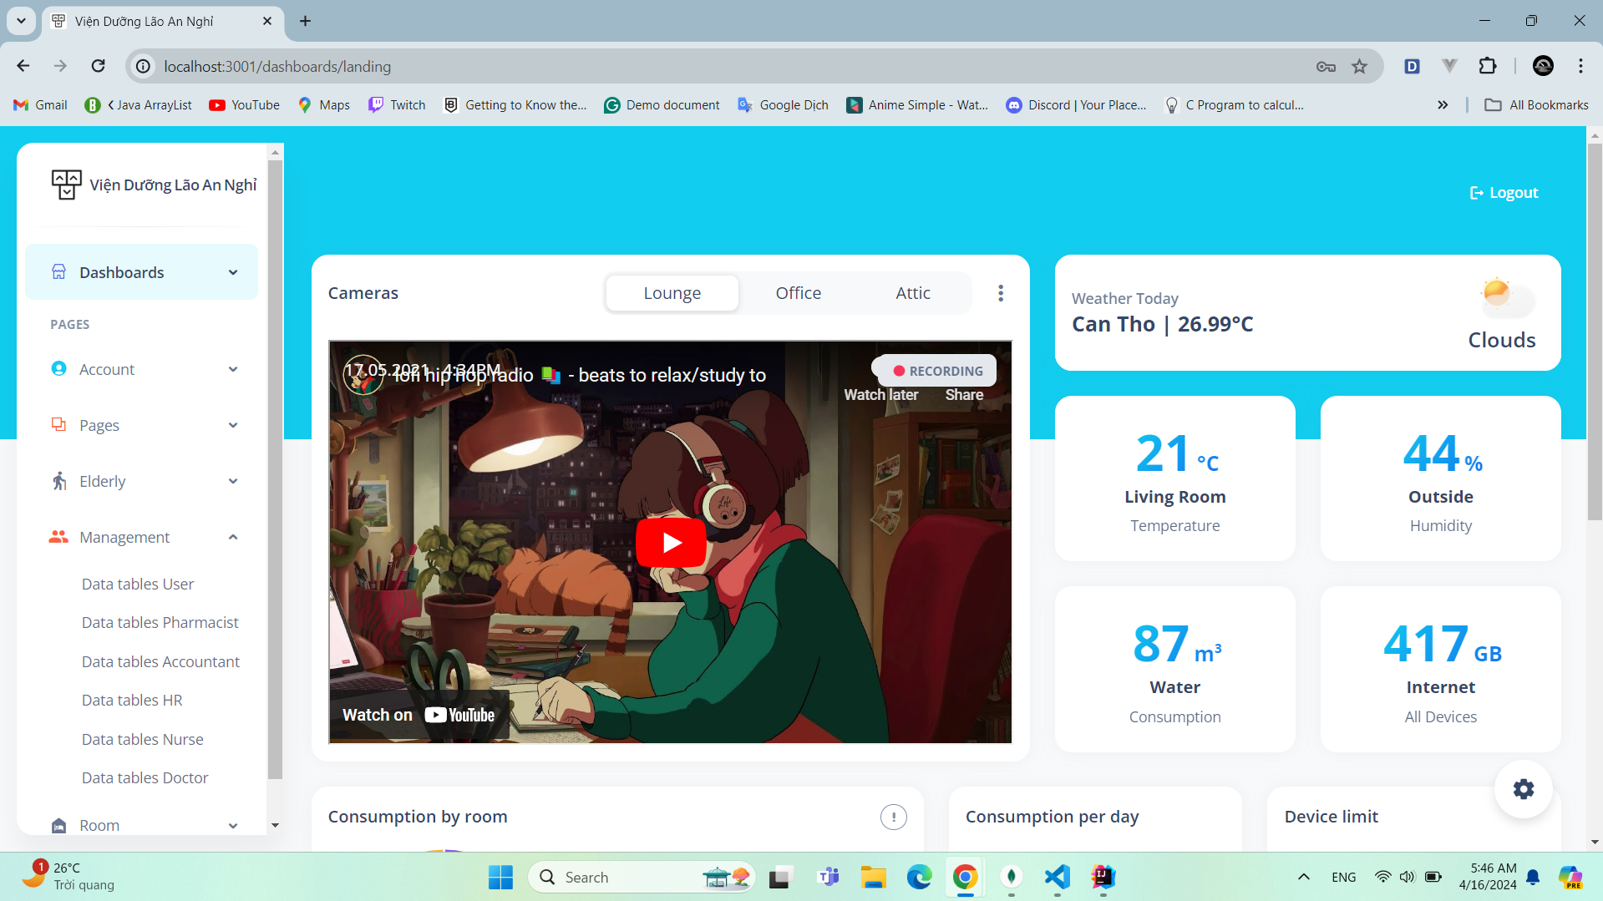

## 2.3. Accountant

When users using an Accountant account log in to the system, they will see the interface as below. The Accountant role in the system will manage all information related to nursing home finances, including the following functions:

+ Manage financial information of nursing homes.

+ View financial charts and parameters in nursing homes.

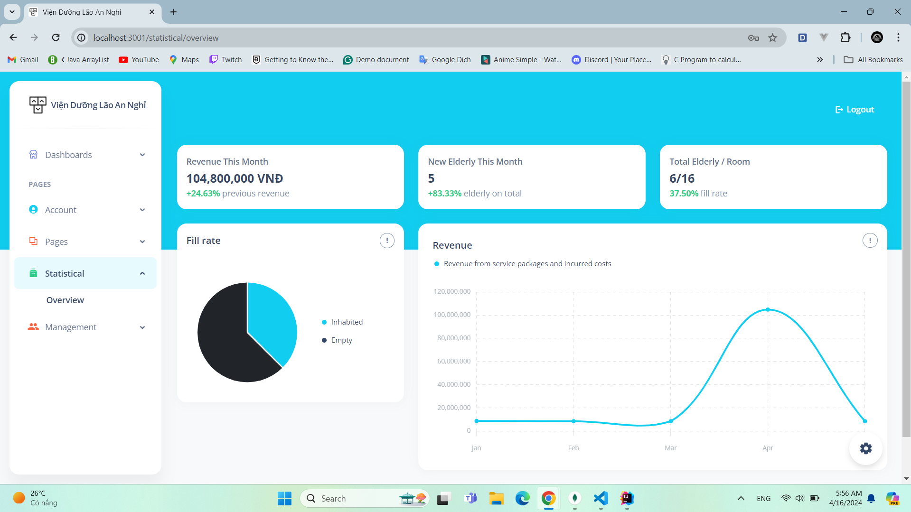

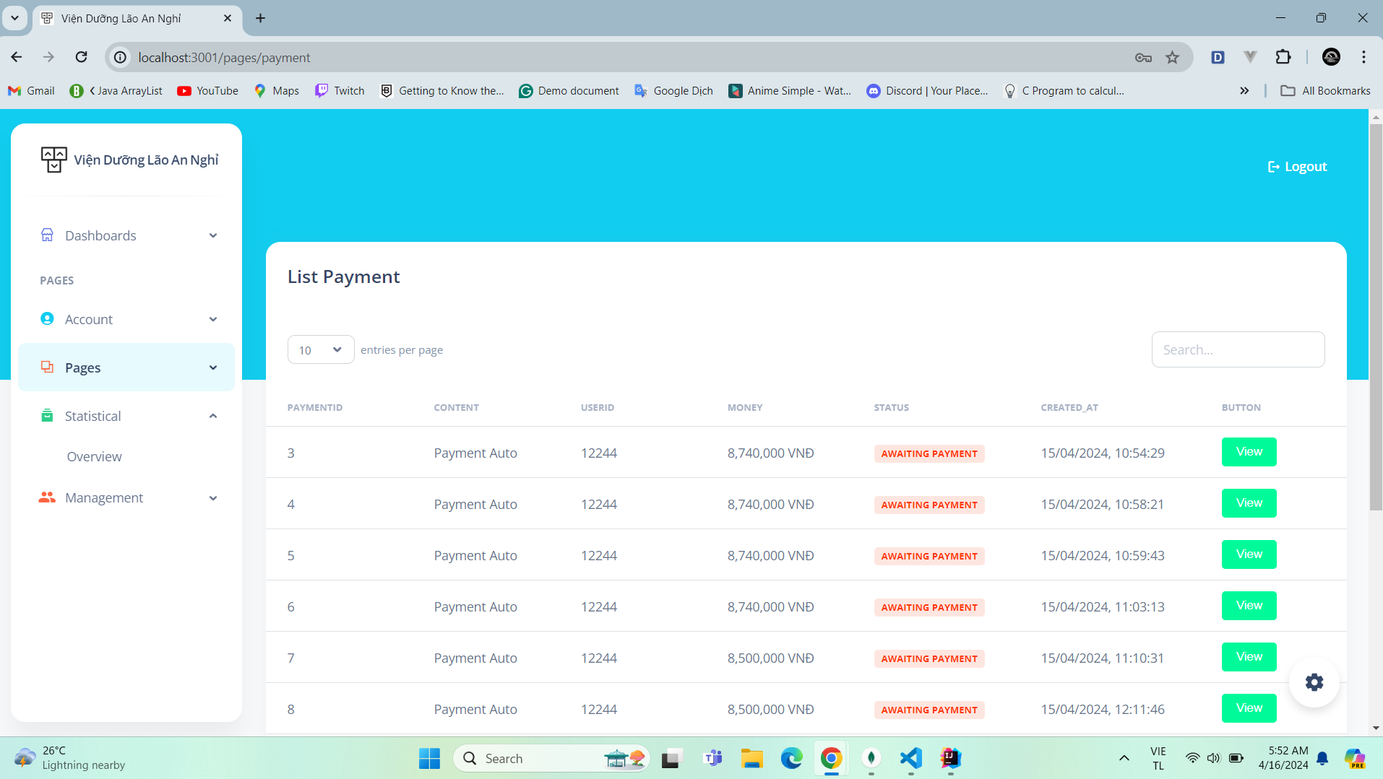

## 2.4. Doctor

When a user using a doctor account logs into the system, he or she will see the interface as below. The role of the doctor in the system will be to examine and update information on the health status of the elderly in the nursing home.

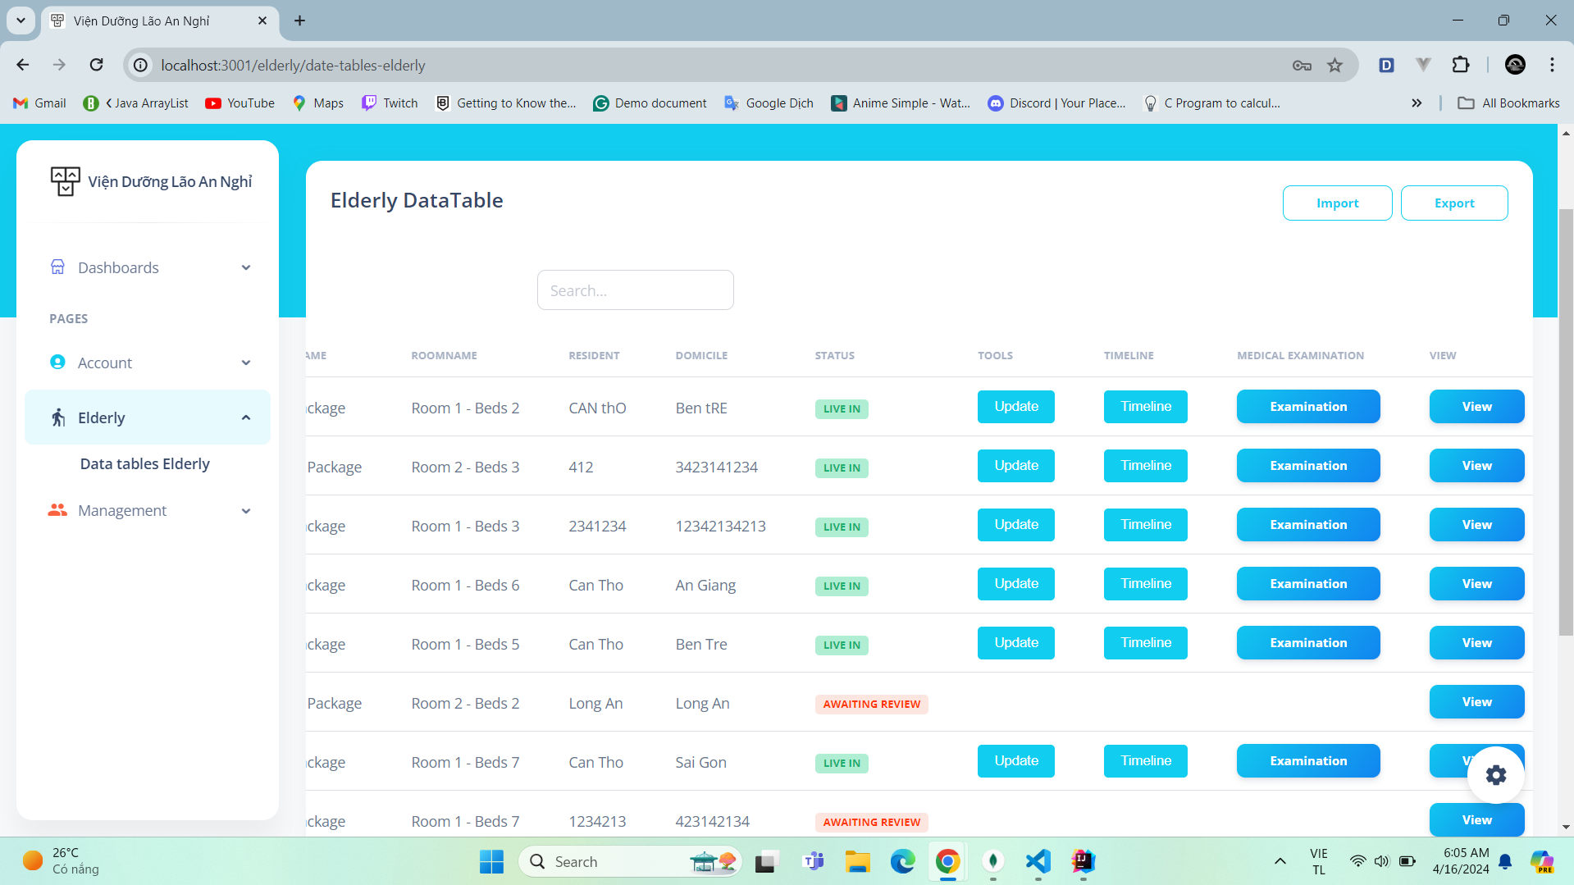

## 2.5. Nurse

When users use a nurse account to log in to the system, they will see the interface as below. The nurse role in the system will be able to manage the elderly's activity schedules and view their medical examination schedules.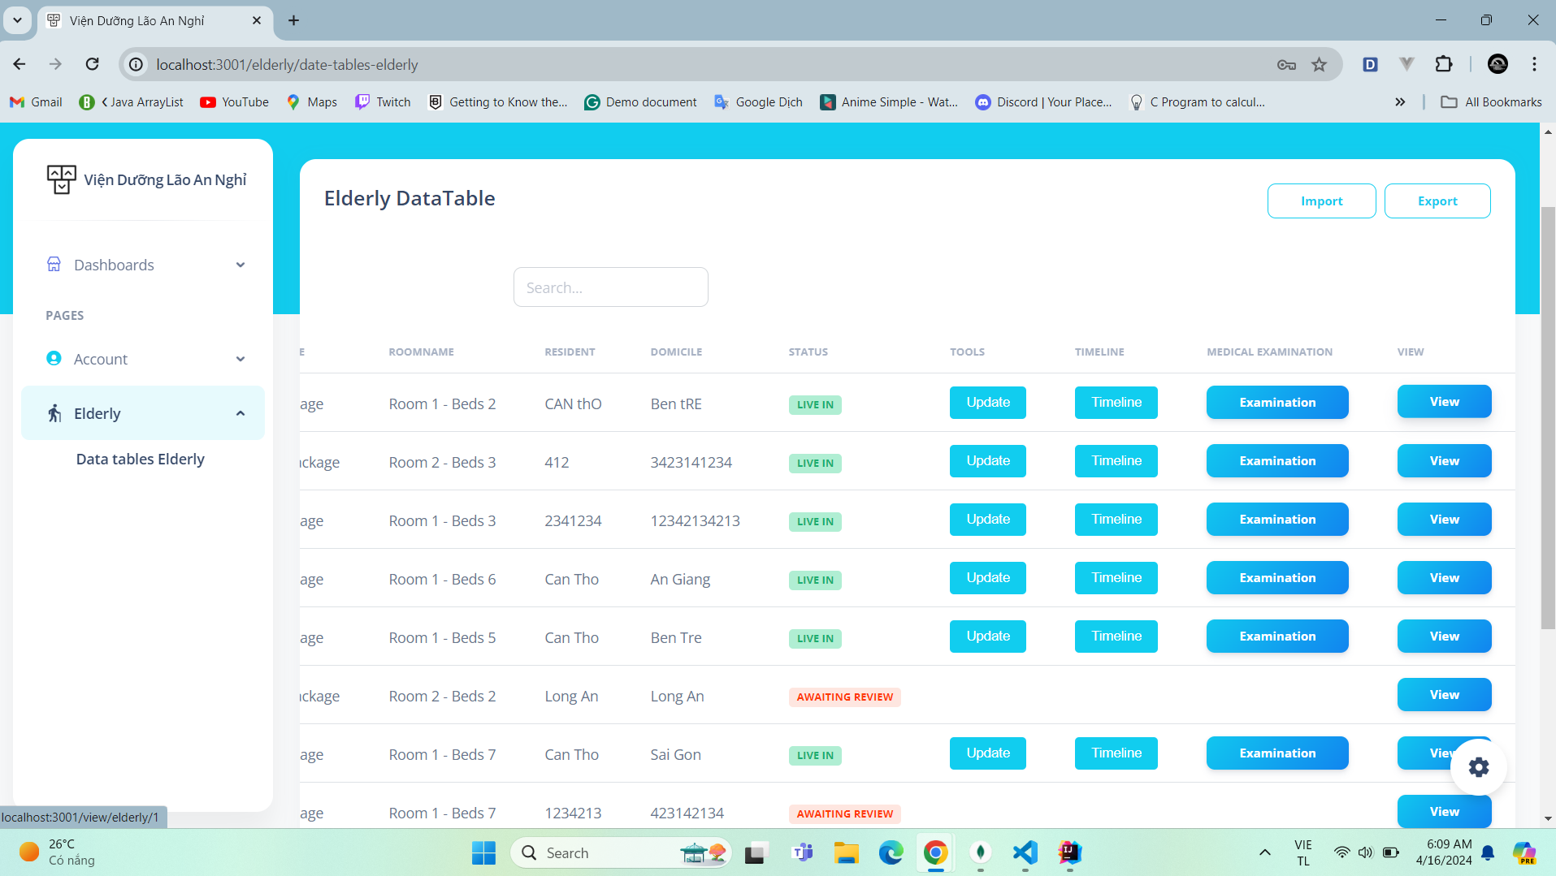

## 2.6. User

When the user uses a user account to log into the system, he will see the interface as below. The user role in the system will be able to view information about the health and daily activities of the elderly people admitted to the nursing home.

